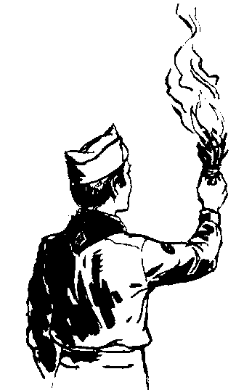
Leading the way...

 |  |  | 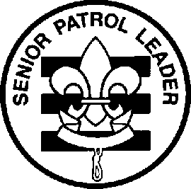
 |  | 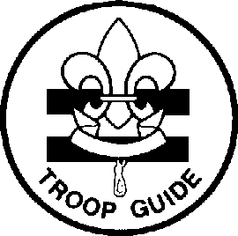 | 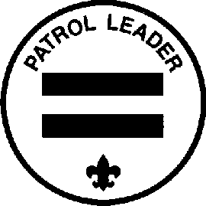 | 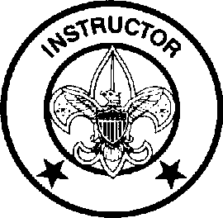 | 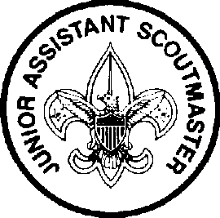
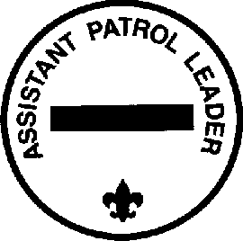 | 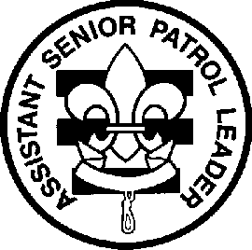 | 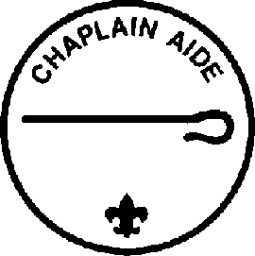 |  | 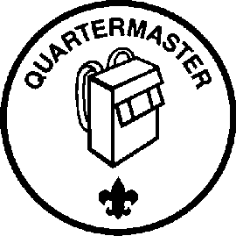 | 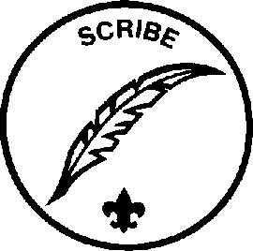 | 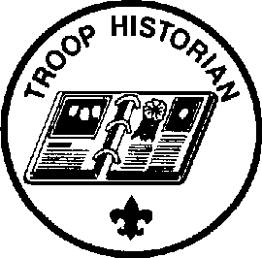

Troop 455 Scout Leadership Positions
Duties and Responsibilities

November 2015
Leading the way...
What does that mean?
Think about being a Cub Scout. You came to den meetings and did a lot of different and fun things. But who decided what to do and who planned the activities? The Den Leaders, right?
Sports teams are a lot of fun, too. But who decides who plays what position, who's on the starting lineup and when to substitute? The coach, right?
There is one thing that makes Scouting different from all other youth groups. Do you know what it is?
Well, it is not the uniform. Every soccer, basketball, and baseball team has a uniform.
It is not the fun activities. There are a lot of other things that are fun.
And it certainly isn't cleaning dirty pots and pans on a campout!
What makes Scouting special is that YOU make the decisions!
That's right! YOU run the troop. Baden-Powell made it very plain in Aids to Scoutmastership when he wrote,
“The best progress is made in those Troops where power and responsibility are really put into the hands of the Patrol Leaders.”
This is real decision making power. And not it's not just Patrol Leaders. All of the troop leadership positions have a hand in making the Troop run. As a troop leader you will:
Plan and run troop meetings,
Pick troop outings, where to camp, what to do,
Plan advancement opportunities for all troop members
Select High-Adventure programs
Determine troop policy
Help other Scouts along the trail to Eagle.
Sound cool? It really is! The adults are there to provide support but YOU will be making the decisions.
Because being a leader is more than just sewing on a patch we have put together job descriptions for the troop leadership positions. They will give you a good idea of what each job is all about and what you will be required to do.
Here's how to be considered for a position. First read the job descriptions, qualifications, and job responsibilities. Then decide what you want to do and talk it over with your parents. You can also talk it over with other Scouts who have served in that position. Finally, get a troop job application form, fill it out, have your parent(s) read and sign it and turn it in.
So, are you ready to "Lead the way"? We sure hope so!

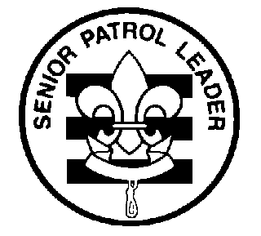
Troop 455
Leadership Position Description
SENIOR PATROL LEADER
GENERAL INFORMATION
Type: Elected by the members of the troop to position of Assistant Senior Patrol Leader; advances to SPL position upon completion of term as ASPL.
Term: 6 months
Reports to: Scoutmaster
Description: The Senior Patrol Leader is elected by the Scouts to represent them as the top junior leader in the troop.
Comments: The Senior Patrol Leader is the focal point of the troop. He needs to attend as close to all troop functions as possible. One of the major parts of the SPL's job is to appoint other troop leaders. He must choose leaders who are able, not just his friends or other popular Scouts.
QUALIFICATIONS
Age: none
Rank: 1st Class or higher
Experience: Previous service as SPL, ASPL, PL, or APL
Attendance: 75% over previous 6 months
PERFORMANCE REQUIREMENTS
Training: You must attend the troop Junior Leader Training even if you have attended in the past.
Attendance: You are expected to attend 85% of all troop meetings, Patrol Leaders' Council meetings, outings, and service projects. If your attendance is low, or if you have three (3) unexcused absences in a row, you can be removed from office.
Effort: You are expected to give this job your best effort.
GENERAL LEADERSHIP RESPONSIBILITIES
Uniform: Set the example by wearing your uniform correctly. This means that you will wear all of the parts of the troop uniform, shirttail tucked in, with all required badges in their correct locations.
Behavior: Set the example by living the Scout Oath and Law in your everyday life. Show Scout Spirit in everything you say and do.
Attendance: Set the example by being an active Scout. Be on-time for meetings and activities. You must call or email the Scoutmaster if you are not going to be at a meeting or if you suddenly have to miss an outing. You also need to make sure that the Assistant Senior Patrol Leader is ready to assume your responsibilities.
SPECIFIC LEADERSHIP RESPONSIBILITIES
Runs all troop meetings, events, activities, and the annual program planning conference.
Runs the Patrol Leader's Council meeting.
Appoints other troop junior leaders with the advice and counsel of the Scoutmaster.
Assigns duties and responsibilities to junior leaders.
Assists the Scoutmaster with Junior Leader Training.
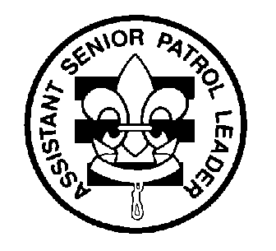
Troop 455
Leadership Position Description
ASSISTANT SENIOR PATROL LEADER

GENERAL INFORMATION
Type: Elected by the members of the troop to position of Assistant Senior Patrol Leader; advances to SPL position upon completion of term as ASPL.
Term: 6 months
Reports to: Senior Patrol Leader
Description: The Assistant Senior Patrol Leader is the second highest ranking patrol leader in the troop. The Assistant Senior Patrol Leader acts as the Senior Patrol Leader in the absence of the SPL or when called upon. He also provides leadership to other junior leaders in the troop.
Comments: The most important part of the ASPL position is his work with the other junior leaders. The ASPL should be familiar with the other positions and stay current with the work being done.
QUALIFICATIONS
Age: none
Rank: 1st Class or higher
Experience: none
Attendance: 50% over the previous 6 months
PERFORMANCE REQUIREMENTS
Training: You must attend the troop Junior Leader Training even if you have attended in the past.
Attendance: You are expected to attend 80% of all troop meetings, Patrol Leaders' Council meetings, outings, and service projects. If your attendance is low, or if you have three (3) unexcused absences in a row, you can be removed from office.
Effort: You are expected to give this job your best effort.
GENERAL LEADERSHIP RESPONSIBILITIES
Uniform: Set the example by wearing your uniform correctly. This means that you will wear all of the parts of the troop uniform, shirttail tucked in, with all required badges in their correct locations.
Behavior: Set the example by living the Scout Oath and Law in your everyday life. Show Scout Spirit in everything you say and do.
Attendance: Set the example by being an active Scout. Be on-time for meetings and activities. You must call or email the Senior Patrol Leader or Scoutmaster if you are not going to be at a meeting or if you suddenly have to miss an outing. You also need to make sure that someone will assume your responsibilities.
SPECIFIC LEADERSHIP RESPONSIBILITIES
Helps the Senior Patrol Leader lead meetings and activities.
Runs the troop in the absence of the Senior Patrol Leader.
Helps train and supervise the Troop Scribe, Quartermaster, Instructor, Librarian, Historian, and Chaplin Aide.
Serves as a member of the Patrol Leader's Council.

Troop 455
Leadership Position Description
PATROL LEADER
GENERAL INFORMATION
Type: Elected by members of the patrol
Term: 6 months
Reports to: Senior Patrol Leader
Description: The Patrol Leader is the elected leader of his patrol. He represents his patrol on the Patrol Leader's Council.
Comments: The Patrol Leader may easily be the most important job in the troop. He has the closest contact with the patrol members and is in the perfect position to help and guide them. The Patrol Leaders, along with the Senior Patrol Leader and Assistant Senior Patrol Leader are the primary members of the Patrol Leaders' Council.
QUALIFICATIONS
Age: none
Rank: none
Experience: none
Attendance: 75% over previous 6 months
PERFORMANCE REQUIREMENTS
Training: You must attend the troop Junior Leader Training even if you have attended in the past.
Attendance: You are expected to attend 80% of all troop meetings, Patrol Leaders' Council meetings, outings, and service projects. If your attendance is low, or if you have three (3) unexcused absences in a row, you can be removed from office.
Effort: You are expected to give this job your best effort.
GENERAL LEADERSHIP RESPONSIBILITIES
Uniform: Set the example by wearing your uniform correctly. This means that you will wear all of the parts of the troop uniform, shirttail tucked in, with all required badges in their correct locations.
Behavior: Set the example by living the Scout Oath and Law in your everyday life. Show Scout Spirit in everything you say and do.
Attendance: Set the example by being an active Scout. Be on-time for meetings and activities. You must call or email the Senior Patrol Leader or Scoutmaster if you are not going to be at a meeting or if you suddenly have to miss an outing. You also need to make sure that the Assistant Patrol Leader is ready to assume your responsibilities.
SPECIFIC LEADERSHIP RESPONSIBILITIES
Appoints the Assistant Patrol Leader.
Represents the patrol on the Patrol Leader's Council
Plans and steers patrol meeting Changes
Helps Scouts advance

Reports attendance of his patrol at troop meetings and troop activities to the Troop Scribe
Keeps patrol members informed
Knows what his patrol members and other leaders can do.
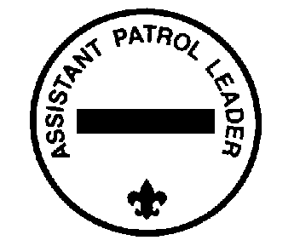
Troop 455
Leadership Position Description
ASSISTANT PATROL LEADER
GENERAL INFORMATION
Type: Appointed by the Patrol Leader
Term: 6 months
Reports to: Patrol Leader
Description: The Assistant Patrol Leader is appointed by the Patrol Leader and leads the patrol in his absence.
Comments: Substituting for the Patrol Leader is only part of the Assistant Patrol Leader's job. The APL actively helps run the patrol.
QUALIFICATIONS
Age: none
Rank: none
Experience: none
Attendance: 50% over previous 6 months
PERFORMANCE REQUIREMENTS
Training: You must attend the troop Junior Leader Training even if you have attended in the past.
Attendance: You are expected to attend 75% of all troop meetings, outings, and service projects. You are expected to be at Patrol Leaders’ Council meetings, when requested by your Patrol Leader. If your attendance is low, or if you have three (3) unexcused absences in a row, you can be removed from office.
Effort: You are expected to give this job your best effort.
GENERAL LEADERSHIP RESPONSIBILITIES
Uniform: Set the example by wearing your uniform correctly. This means that you will wear all of the parts of the troop uniform, shirttail tucked in, with all required badges in their correct locations.
Behavior: Set the example by living the Scout Oath and Law in your everyday life. Show Scout Spirit in everything you say and do.
Attendance: Set the example by being an active Scout. Be on-time for meetings and activities. You must call or email the Patrol Leader or Senior Patrol Leader if you are not going to be at a meeting or if you suddenly have to miss an outing. You also need to make sure that someone will assume your responsibilities.
SPECIFIC LEADERSHIP RESPONSIBILITIES
Helps the Patrol Leader plan and steer patrol meetings and activities.
Helps the Patrol Leader keep patrol members informed.
Helps the patrol get ready for all troop activities.
Represents his patrol at Patrol Leader's Council meetings when the Patrol Leader cannot attend.
Lends a hand controlling the patrol and building patrol spirit.

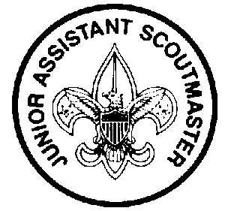
Troop 455
Leadership Position Description
JUNIOR ASSISTANT SCOUTMASTER
GENERAL INFORMATION
Type: Appointed by the Scoutmaster
Term: 1 year
Reports to: Scoutmaster
Description: The Junior Assistant Scoutmaster serves in the capacity of an Assistant Scoutmaster except where legal age and maturity are required. He must be at least 16 years old and not yet 18. He's appointed by the Scoutmaster because of his leadership ability.
Comments: In many cases the JASM has the same responsibilities as an Assistant Scoutmaster.
QUALIFICATIONS
Age: At least 16 years old
Rank: Eagle
Experience: Previous leadership positions
Attendance: 75% over the previous 6 months
PERFORMANCE REQUIREMENTS
Training: You must attend the troop Junior Leader Training even if you have attended in the past.
Attendance: You are expected to attend 80% of all troop meetings, outings, and service projects. You are expected to be at Patrol Leaders’ Council meetings, when requested by the Scoutmaster. If your attendance is low, or if you have three (3) unexcused absences in a row, you can be removed from office.
Effort: You are expected to give this job your best effort.
GENERAL LEADERSHIP RESPONSIBILITIES
Uniform: Set the example by wearing your uniform correctly. This means that you will wear all of the parts of the troop uniform, shirttail tucked in, with all required badges in their correct locations.
Behavior: Set the example by living the Scout Oath and Law in your everyday life. Show Scout Spirit in everything you say and do.
Attendance: Set the example by being an active Scout. Be on-time for meetings and activities. You must call or email the Senior Patrol Leader or Scoutmaster if you are not going to be at a meeting or if you suddenly have to miss an outing. You also need to make sure that someone will assume your responsibilities.
SPECIFIC LEADERSHIP RESPONSIBILITIES
Functions as an Assistant Scoutmaster.
Performs duties as assigned by the Scoutmaster.

Troop 455
Leadership Position Description
DEN CHIEF
GENERAL INFORMATION
Type: Appointed by the Scoutmaster
Term: 1 year
Reports to: Scoutmaster and Den Leader
Description: The Den Chief works with the Cub Scouts, Webelos Scouts, and Den Leaders in the Cub Scout pack.
Comments: The Den Chief provides knowledge of games and Scout skills that many Den Leaders lack. The Den Chief is also a recruiter for the troop. This function is important because no troop can thrive without new members and most new members will come from Cub Scouting.
QUALIFICATIONS
Age: 14 or older
Rank: First Class or higher
Experience: none
Attendance: 75% over previous 6 months
PERFORMANCE REQUIREMENTS
Training: You must attend the troop Junior Leader Training even if you have attended in the past.
Attendance: You are expected to attend 75% of all troop meetings, outings, and service projects. You are expected to be at Patrol Leaders’ Council meetings, when requested by the Scoutmaster. If your attendance is low, or if you have three (3) unexcused absences in a row, you can be removed from office.
In terms of attendance with your den, you are expected to attend 90% of den meetings and pack functions. You must inform the Den Leader if you will be absent.
Effort: You are expected to give this job your best effort.
GENERAL LEADERSHIP RESPONSIBILITIES
Uniform: Set the example by wearing your uniform correctly. This means that you will wear all of the parts of the troop uniform, shirttail tucked in, with all required badges in their correct locations.
Behavior: Set the example by living the Scout Oath and Law in your everyday life. Show Scout Spirit in everything you say and do.
Attendance: Set the example by being an active Scout. Be on-time for meetings and activities. You must call or email the Senior Patrol Leader or Scoutmaster if you are not going to be at a meeting or if you suddenly have to miss an outing. You also need to make sure that someone will assume your responsibilities.
SPECIFIC LEADERSHIP RESPONSIBILITIES
Knows the purposes of Cub Scouting
Helps Cub Scouts advance through Cub Scout ranks.
Encourages Cub Scouts to join a Boy Scout troop upon graduation.
Assists with activities in the den meetings.
Is a friend to the boys in the den.
Helps out at weekly den meetings and monthly pack meetings.
Meets with adult members of the den, pack, and troop as necessary.

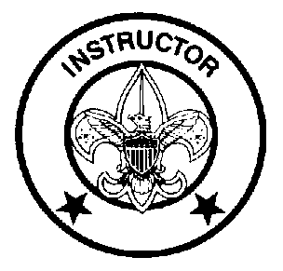
Troop 455
Leadership Position Description
INSTRUCTOR
GENERAL INFORMATION
Type: Appointed by the Scoutmaster
Term: 1 year
Reports to: Scoutmaster
Description: The Instructor teaches Scouting skills.
Comments: The Instructor will work closely with both the Troop Guide and with the Assistant Scoutmaster for new Scouts. The Instructor does not have to be an expert but should be able to teach the Scoutcraft skills needed for Tenderfoot, Second Class, and First Class ranks. The troop can have more than one instructor.
QUALIFICATIONS
Age: 14 or older
Rank: 1st Class or higher
Experience: none
Attendance: 50% over previous 6 months
PERFORMANCE REQUIREMENTS
Training: You must attend the troop Junior Leader Training even if you have attended in the past.
Attendance: You are expected to attend 75% of all troop meetings, outings, and service projects. You are expected to be at Patrol Leaders’ Council meetings, when requested by the Scoutmaster. If your attendance is low, or if you have three (3) unexcused absences in a row, you can be removed from office.
Effort: You are expected to give this job your best effort.
GENERAL LEADERSHIP RESPONSIBILITIES
Uniform: Set the example by wearing your uniform correctly. This means that you will wear all of the parts of the troop uniform, shirttail tucked in, with all required badges in their correct locations.
Behavior: Set the example by living the Scout Oath and Law in your everyday life. Show Scout Spirit in everything you say and do.
Attendance: Set the example by being an active Scout. Be on-time for meetings and activities. You must call or email the Senior Patrol Leader or Scoutmaster if you are not going to be at a meeting or if you suddenly have to miss an outing. You also need to make sure that someone will assume your responsibilities.
SPECIFIC LEADERSHIP RESPONSIBILITIES
Teaches basic Scouting skills in troop and patrols.

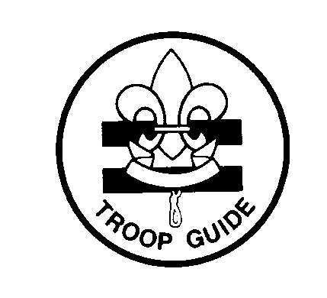
Troop 455
Leadership Position Description
TROOP GUIDE
GENERAL INFORMATION
Type: Appointed by the Scoutmaster
Term: 1 year
Reports to: Scoutmaster
Description: The Troop Guide works with new Scouts. He helps them feel comfortable and earn their First Class rank in their first year.
Comments: The first year as a Boy Scout is a critical time with new places, new people, new rules, and new activities. The Troop Guide is a friend to the new Scouts and makes first year fun and successful. This is an important position.
QUALIFICATIONS
Age: 14 or older
Rank: 1st Class or higher
Experience: none
Attendance: 75% over previous 6 months
PERFORMANCE REQUIREMENTS
Training: You must attend the troop Junior Leader Training even if you have attended in the past.
Attendance: You are expected to attend 90% of all troop meetings, Patrol Leaders' Council meetings (when a ‘New Scout’ Patrol exists), outings, and service projects. If your attendance is low, or if you have three (3) unexcused absences in a row, you can be removed from office.
Effort: You are expected to give this job your best effort.
GENERAL LEADERSHIP RESPONSIBILITIES
Uniform: Set the example by wearing your uniform correctly. This means that you will wear all of the parts of the troop uniform, shirttail tucked in, with all required badges in their correct locations.
Behavior: Set the example by living the Scout Oath and Law in your everyday life. Show Scout Spirit in everything you say and do.
Attendance: Set the example by being an active Scout. Be on-time for meetings and activities. You must call or email the Senior Patrol Leader or Scoutmaster if you are not going to be at a meeting or if you suddenly have to miss an outing. You also need to make sure that someone will assume your responsibilities.
SPECIFIC LEADERSHIP RESPONSIBILITIES
Introduces new Scouts to troop operations.
Guides new Scouts through early Scouting activities
Shields new Scouts from harassment by older Scouts.
Helps new Scouts earn First Class in their first year.
Teaches basic Scout skills.
Coaches the patrol leader of the new Scout patrol on his duties.
Works with the patrol leader at Patrol Leaders' Council meetings.
Attends Patrol Leaders' Council meetings with the patrol leader of the new Scout patrol.
Assists the Assistant Scoutmaster with training.
Counsels individual Scouts on Scouting challenges.

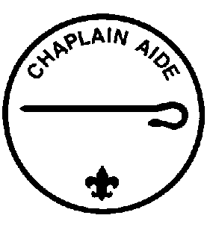
Troop 455
Leadership Position Description
CHAPLIN AIDE
GENERAL INFORMATION
Type: Appointed by the Senior Patrol Leader
Term: 6 months
Reports to: Assistant Senior Patrol Leader
Description: The Chaplin Aide works with the Troop Chaplin to meet the religious needs of Scouts in the troop. He also works to promote the religious awards program.
Comments: "Duty to God" is one of the core beliefs of Scouting. The Chaplin Aide helps everyone in the troop by preparing short religious observations for campouts and other functions. The Chaplin Aide does not always lead the observation himself and can have other troop members help.
QUALIFICATIONS
Age: none
Rank: none
Experience: none
Attendance: 50% over the previous 6 months
PERFORMANCE REQUIREMENTS
Training: You must attend the troop Junior Leader Training even if you have attended in the past.
Attendance: You are expected to attend 60% of all troop meetings, outings, and service projects. You are expected to be at Patrol Leaders’ Council meetings, when requested by the ASPL. If your attendance is low, or if you have three (3) unexcused absences in a row, you can be removed from office.
Effort: You are expected to give this job your best effort.
GENERAL LEADERSHIP RESPONSIBILITIES
Uniform: Set the example by wearing your uniform correctly. This means that you will wear all of the parts of the troop uniform, shirttail tucked in, with all required badges in their correct locations.
Behavior: Set the example by living the Scout Oath and Law in your everyday life. Show Scout Spirit in everything you say and do.
Attendance: Set the example by being an active Scout. Be on-time for meetings and activities. You must call or email the Assistant Senior Patrol Leader or Senior Patrol Leader if you are not going to be at a meeting or if you suddenly have to miss an outing. You also need to make sure that someone will assume your responsibilities.
SPECIFIC LEADERSHIP RESPONSIBILITIES
Assists the Troop Chaplin with religious services at troop activities.
Tells Scouts about the religious emblem program for their faith.
Makes sure religious holidays are considered during troop program planning.
Helps plan for religious observance in troop activities.

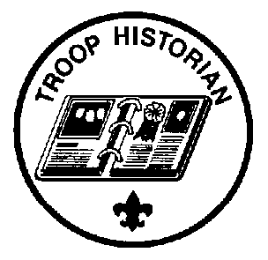
Troop 455
Leadership Position Description
TROOP HISTORIAN
GENERAL INFORMATION
Type: Appointed by the Senior Patrol Leader
Term: 6 months
Reports to: Assistant Senior Patrol Leader
Description: The Troop Historian keeps a historical record or scrapbook of troop activities.
Comments: The true value of a good Historian does not show up until years later. The Historian provides material for displays and presentations of current activities. In addition, the work of the Historian provides a link with the past.
QUALIFICATIONS
Age: none
Rank: none
Experience: none, but interest in photography is helpful
Attendance: 50% over the previous 6 months
PERFORMANCE REQUIREMENTS
Training: You must attend the troop Junior Leader Training even if you have attended in the past.
Attendance: You are expected to attend 60% of all troop meetings, outings, and service projects. You are expected to be at Patrol Leaders’ Council meetings, when requested by the ASPL. If your attendance is low, or if you have three (3) unexcused absences in a row, you can be removed from office.
Effort: You are expected to give this job your best effort.
GENERAL LEADERSHIP RESPONSIBILITIES
Uniform: Set the example by wearing your uniform correctly. This means that you will wear all of the parts of the troop uniform, shirttail tucked in, with all required badges in their correct locations.
Behavior: Set the example by living the Scout Oath and Law in your everyday life. Show Scout Spirit in everything you say and do.
Attendance: Set the example by being an active Scout. Be on-time for meetings and activities. You must call or email the Assistant Senior Patrol Leader or the Senior Patrol Leader if you are not going to be at a meeting or if you suddenly have to miss an outing. You also need to make sure that someone will assume your responsibilities.
SPECIFIC LEADERSHIP RESPONSIBILITIES
Gathers pictures and narrative about troop activities; then provides them to the troop webmaster and keeps them in a historical file or scrapbook.
Takes care of troop trophies, ribbons, and souvenirs of troop activities.
Keeps information about former members of the troop, such as listing of Eagle Scouts and Scoutmasters.
Keeps Troop PLC information sent to him by the Troop Scribe.

Troop 455
Leadership Position Description
TROOP LIBRARIAN
GENERAL INFORMATION
Type: Appointed by the Senior Patrol Leader
Term: 6 months
Reports to: Assistant Senior Patrol Leader
Description: The Troop Librarian takes care of troop literature.
Comments: The library contains books of historical value as well as current materials. All together, the library is a troop resource worth hundreds of dollars. The Librarian manages this resource for the troop.
QUALIFICATIONS
Age: none
Rank: none
Experience: none
Attendance: 50% over the previous 6 months
PERFORMANCE REQUIREMENTS
Training: You must attend the troop Junior Leader Training even if you have attended in the past.
Attendance: You are expected to attend 60% of all troop meetings, outings, and service projects. You are expected to be at Patrol Leaders’ Council meetings, when requested by the ASPL. If your attendance is low, or if you have three (3) unexcused absences in a row, you can be removed from office.
Effort: You are expected to give this job your best effort.
GENERAL LEADERSHIP RESPONSIBILITIES
Uniform: Set the example by wearing your uniform correctly. This means that you will wear all of the parts of the troop uniform, shirttail tucked in, with all required badges in their correct locations.
Behavior: Set the example by living the Scout Oath and Law in your everyday life. Show Scout Spirit in everything you say and do.
Attendance: Set the example by being an active Scout. Be on-time for meetings and activities. You must call or email the Assistant Senior Patrol Leader or the Senior Patrol Leader if you are not going to be at a meeting or if you suddenly have to miss an outing. You also need to make sure that someone will assume your responsibilities.
SPECIFIC LEADERSHIP RESPONSIBILITIES
Sets up and takes care of a troop library
Keeps records of books and pamphlets owned by the troop.
Recommends new or replacement items to the ASPL, as needed. Obtains authorized replacement items.
Keeps books and pamphlets available for borrowing.
Keeps a system for checking books and pamphlets in and out.
Follows up on late returns.
Issues vouchers for purchase of used merit badge books.

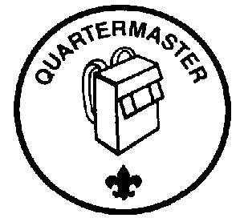
Troop 455
Leadership Position Description
TROOP QUARTERMASTER
GENERAL INFORMATION
Type: Appointed by the Senior Patrol Leader
Term: 6 months
Reports to: Assistant Senior Patrol Leader
Description: The Troop Quartermaster keeps track of troop equipment and sees that it is in good working order.
Comments: The Quartermaster does most of his work around campouts. There are times when the Quartermaster has to be available to check equipment in and out.
QUALIFICATIONS
Age: none
Rank: none
Experience: none
Attendance: 50% over the previous six months
PERFORMANCE REQUIREMENTS
Training: You must attend the troop Junior Leader Training even if you have attended in the past.
Attendance: You are expected to attend 60% of all troop meetings, outings, and service projects. You are expected to be at Patrol Leaders’ Council meetings, when requested by the ASPL. If your attendance is low, or if you have three (3) unexcused absences in a row, you can be removed from office.
Effort: You are expected to give this job your best effort.
GENERAL LEADERSHIP RESPONSIBILITIES
Uniform: Set the example by wearing your uniform correctly. This means that you will wear all of the parts of the troop uniform, shirttail tucked in, with all required badges in their correct locations.
Behavior: Set the example by living the Scout Oath and Law in your everyday life. Show Scout Spirit in everything you say and do.
Attendance: Set the example by being an active Scout. Be on-time for meetings and activities. You must call or email the Assistant Senior Patrol Leader or the Senior Patrol Leader if you are not going to be at a meeting or if you suddenly have to miss an outing. You also need to make sure that someone will assume your responsibilities.
SPECIFIC LEADERSHIP RESPONSIBILITIES
Keeps records on patrol and troop equipment
Makes sure equipment is in good working condition
Issues equipment and makes sure it is returned in good condition
Makes suggestions for new or replacement items
Works with the Troop Committee member responsible for equipment
Gets the US, troop, and patrol flags for meetings and ceremonies and puts them away afterwards.
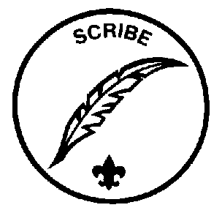
Troop 455
Leadership Position Description
TROOP SCRIBE
GENERAL INFORMATION
Type: Appointed by the Senior Patrol Leader
Term: 6 months
Reports to: Assistant Senior Patrol Leader
Description: The Scribe keeps the troop records. He records the activities of the Patrol Leaders' Council and keeps a record of dues, advancement, and Scout attendance at troop meetings.
Comments: To be a good Scribe you need to attend nearly all troop and Patrol Leaders' Council meetings.
QUALIFICATIONS
Age: none
Rank: none
Experience: none
Attendance: 50% over the previous six months
PERFORMANCE REQUIREMENTS
Training: You must attend the troop Junior Leader Training even if you have attended in the past.
Attendance: You are expected to attend 60% of all troop meetings, Patrol Leaders' Council meetings, outings, and service projects. If your attendance is low, or if you have three (3) unexcused absences in a row, you can be removed from office.
Effort: You are expected to give this job your best effort.
GENERAL LEADERSHIP RESPONSIBILITIES
Uniform: Set the example by wearing your uniform correctly. This means that you will wear all of the parts of the troop uniform, shirttail tucked in, with all required badges in their correct locations.
Behavior: Set the example by living the Scout Oath and Law in your everyday life. Show Scout Spirit in everything you say and do.
Attendance: Set the example by being an active Scout. Be on-time for meetings and activities. You must call or email the Assistant Senior Patrol Leader or the Senior Patrol Leader if you are not going to be at a meeting or if you suddenly have to miss an outing. You also need to make sure that someone will assume your responsibilities.
SPECIFIC LEADERSHIP RESPONSIBILITIES
Attends and keeps a log of Patrol Leaders' Council meetings; sends log to SPL, ASPL, Patrol Leaders, Troop Historian, and Scoutmaster within one week after PLC meeting.
Records individual Scout attendance at troop meetings and events.
Works with the ASM Team to record individual Scout advancement progress towards Trail To First Class (TTFC).
Works with the Troop Committee members responsible for records.

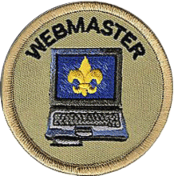
Troop 455
Leadership Position Description
TROOP WEBMASTER
Assistant Webmaster is an appointed (non-elected) cabinet leadership position. The Webmaster is responsible for maintaining the troop web site.

Responsibilities
Work under the supervision of the adult webmaster to:
- Keep the troop web site content up to date with information needed by the troop.
- Maintain the troop distribution lists.
- Manage user access to the troop site.
- Make sure that information posted on the website is correct and that members’ and leaders’ privacy is protected.
- Work with the Troop Historian to publish stories regarding the troop outings and activities to the web site. Publish at least three stories.
- Post Troop photos for at least one event per month to the troop website.
- Work with the Troop Librarian to keep the online Troop Library records accurate.
- Provide at least one News Story per month.
- Ensures the Web site is as youth-run as possible.
- Sets a good example to all other scouts.
- Enthusiastically and correctly wears the Scout uniform.
- Live your life by the Scout Oath and Law.
- Shows Scout spirit at all times in your everyday life

Successful Completion of the Requirements
- Maintains 75% attendance to troop meetings and scheduled events, including weekly meetings and troop outings
- Annual Review by Scoutmaster for Scout spirit, Oath, and Law assessment.

Notes
- Serving as Webmaster can apply towards positions of responsibility requirements for Star, Life, and Eagle.

Troop 455
Leadership Position Description

Bugler

GENERAL INFORMATION
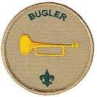
Type: Appointed by the Senior Patrol Leader
Counts for Position of Responsibility for the ranks of Star and Life but not for Eagle.
Term: 6 months
Reports to: Assistant Senior Patrol Leader
Description: The Troop Bugler

QUALIFICATIONS
Age: none
Rank: 1st Class Scout
Experience: Must be able to Play Bugle/Trumpet/Cornet
Must be able to hit High E without cracking (highest note for most bugle calls)
Attendance: 50% over the previous 6 months
PERFORMANCE REQUIREMENTS
Training: You must attend the troop Junior Leader Training even if you have attended in the past.
Attendance: You are expected to attend 60% of all troop meetings, outings, and service projects. You are expected to be at Patrol Leaders’ Council meetings, when requested by the ASPL. If your attendance is low, or if you have three (3) unexcused absences in a row, you can be removed from office.
Effort: You are expected to give this job your best effort.
GENERAL LEADERSHIP RESPONSIBILITIES
Uniform: Set the example by wearing your uniform correctly. This means that you will wear all of the parts of the troop uniform, shirttail tucked in, with all required badges in their correct locations.
Behavior: Set the example by living the Scout Oath and Law in your everyday life. Show Scout Spirit in everything you say and do.
Attendance: Set the example by being an active Scout. Be on-time for meetings and activities. You must call or email the Assistant Senior Patrol Leader or the Senior Patrol Leader if you are not going to be at a meeting or if you suddenly have to miss an outing. You also need to make sure that someone will assume your responsibilities.
SPECIFIC LEADERSHIP RESPONSIBILITIES
- Play bugle as requested by troop leadership.
- Play taps during evening closing ceremony.
- Practice bugling daily until proficient.
- Arrive 5 minutes before the start of troop meetings.
- Participate in outings. Attendance expectation 50%
- Attend troop meetings. Attendance expectation 50%
- Set a good example.
- Wear the field uniform (class A) correctly to all regular troop meetings and religious services.
- Wear the activity uniform (class B t-shirt) to all outings and other troop activities.
- Live by the Scout Oath and Law
- Show scout spirit.
Troop 455
Leadership Position Application
Your Name: Age:
Current Rank:
Current Position: Previous Positions:
Attendance (6 months): (get from Troop Scribe records)
List your first three choices
1st Choice | 2nd Choice | 3rd Choice
For your first choice, use this space to tell why you want this job, how you would do the job, and why you are the best choice for this position.
Scout's Agreement
I have read the job descriptions for these positions. I understand the duties and responsibilities and if selected will carry them out to the best of my ability.
(Signature) (Date)
Parent's Support Agreement
I agree with the commitment my son is making. I promise to support him in attending training, troop meetings, and troop activities as well as with encouragement at home. I realize that once selected his presence is necessary for the smooth functioning of the troop.
(Signature) (Date)

